27.86: a) 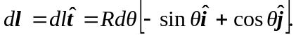 Note that this implies that when 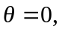the line element points in the + y-direction, and when the angle is 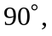 the line element points in the – x-direction. This is in agreement with the diagram.

b) 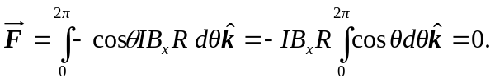
c)
d) 